2021.9.14

已知[Na]o = 120, [Na]i = 12, [K]o = 4, [K]i = 120.

(1) 如果gK / gNa = 10, 求Em.

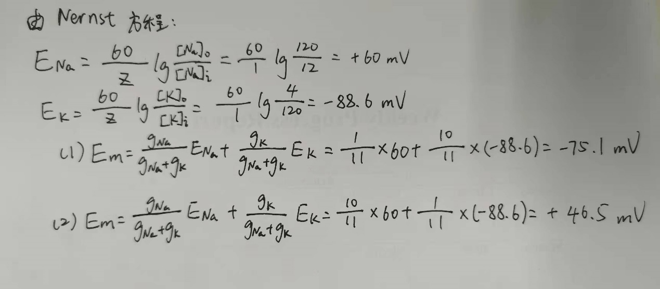(2) 如果gNa / gK = 10, 求Em.

2021.9.28

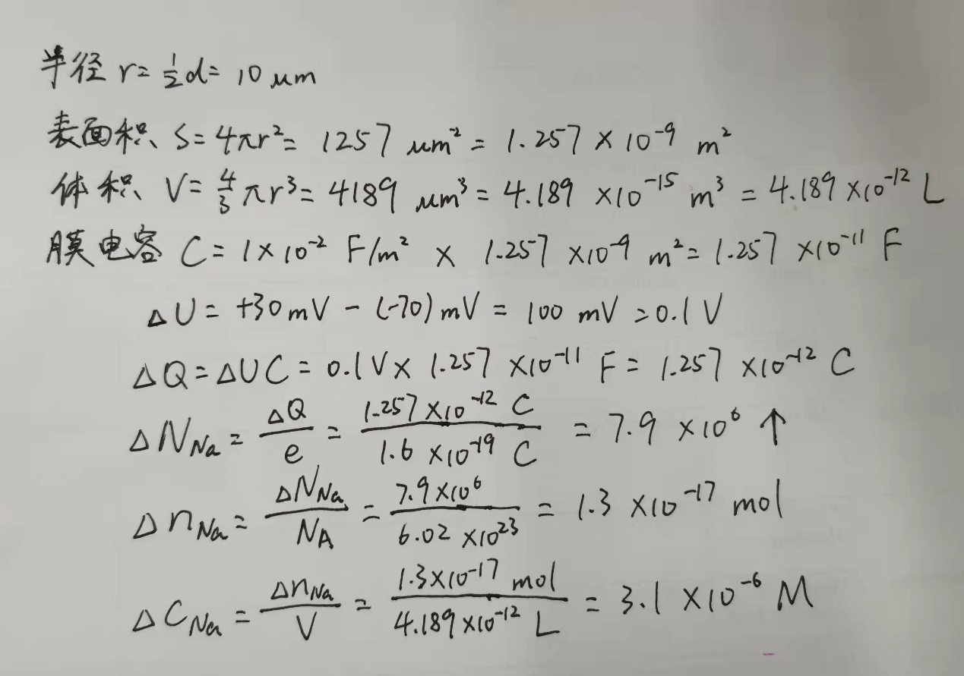 20 µm球形细胞，因钠通道开放从-70 mV去极化到+30 mV, 如果不考虑其它转运电流，有多少个钠离子进入细胞？胞内钠浓度有多大改变？

2021.10.12

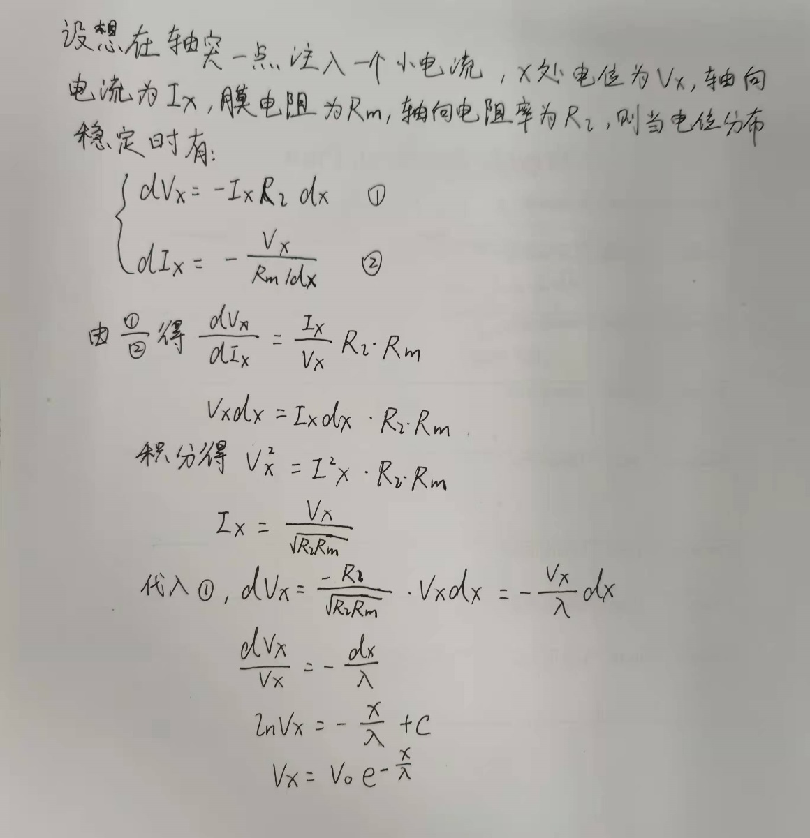 神经纤维的电缆性质*V*(*x*) = *V*0 exp(-*x*/*λ*) , *λ* =推导。

2021.11.23

1. 应激和应急反应的区别和联系。

2. 侏儒症和呆小症的区别。

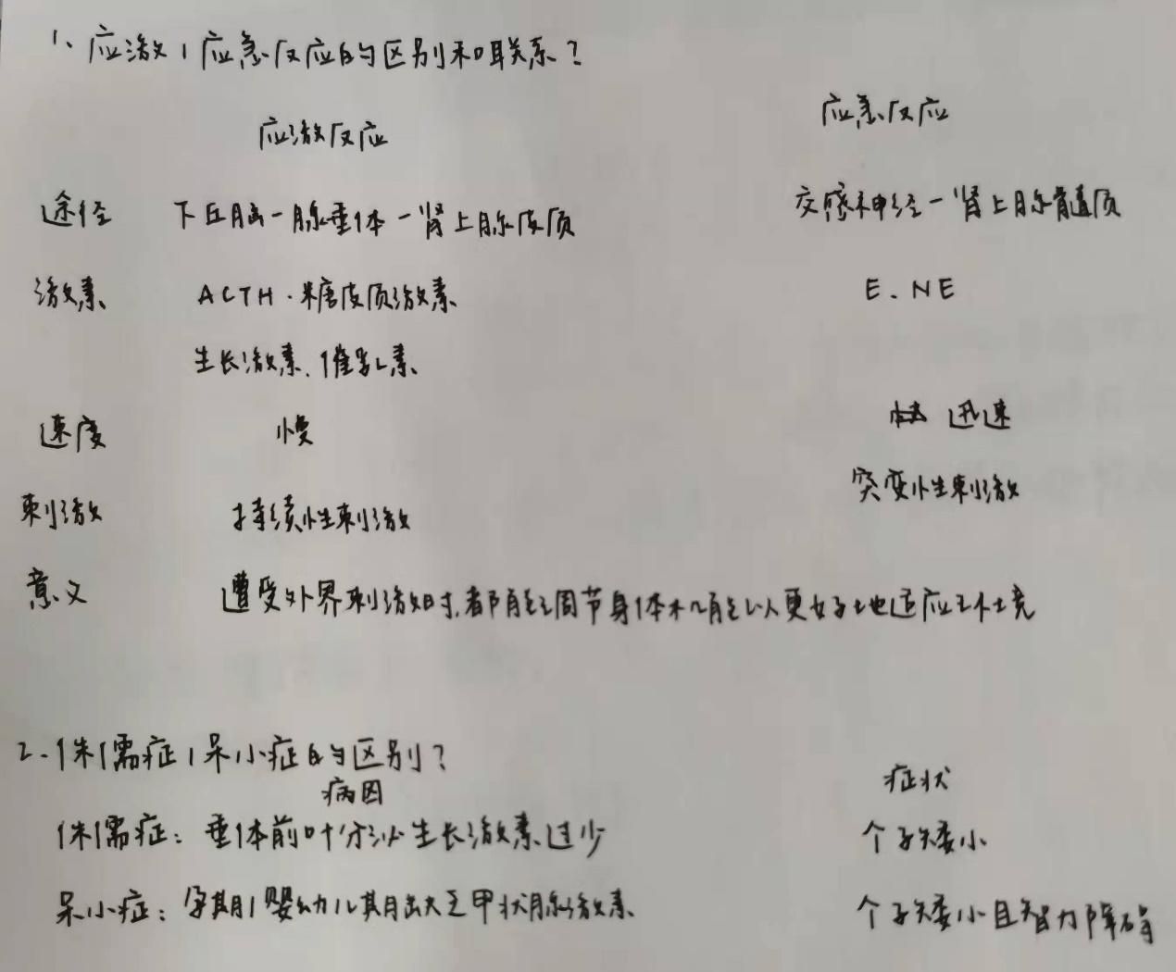

2021.11.30

1. What is neuroscience about?

2. What are the interesting questions you have about the brain?

略

2021.12.2 (3学分)

Design an experiment to measure input resistance and capacity of a neuron.

在电流钳下，给神经元注射指定大小阶跃性电流*I*0，根据稳定后测得的膜电位变化*ΔV*即可计算膜电阻：

*R*m = *ΔV* / *I*0

再根据上述过程中膜电位的变化曲线，用公式：

$V_{m}=IR_{m }\left(1-e^{-\frac{t}{τ}}\right)+V_{0}$

拟合得到时间常数τ，即可计算膜电容：

*C*m = τ / *R*m

2021.12.7

1. How do receptive field changes from bipolar cells, simple cells to complex cells?

2. Are there grandmother cells in the brain? Why?

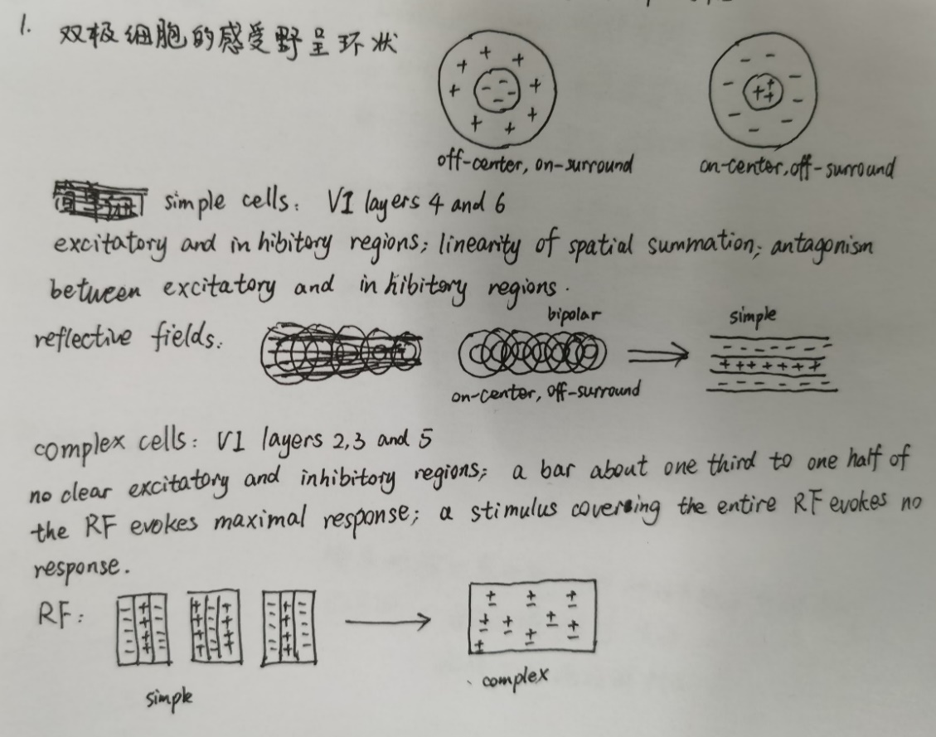

2021.12.14

The absorption of a photon by a rod causes the voltage to decrease from -40 to -42mV for 0.2 seconds. When the cell is at -40mV, the average rate of release of synaptic vesicles is 1000 per 200ms. The rate of synaptic vesicles decreases 10-fold for every 15mV decrease in the rod.

Given that actual number of released vesicles is Poisson distributed, would the absorption of a photon produce a significant change in the rate of vesicle release?

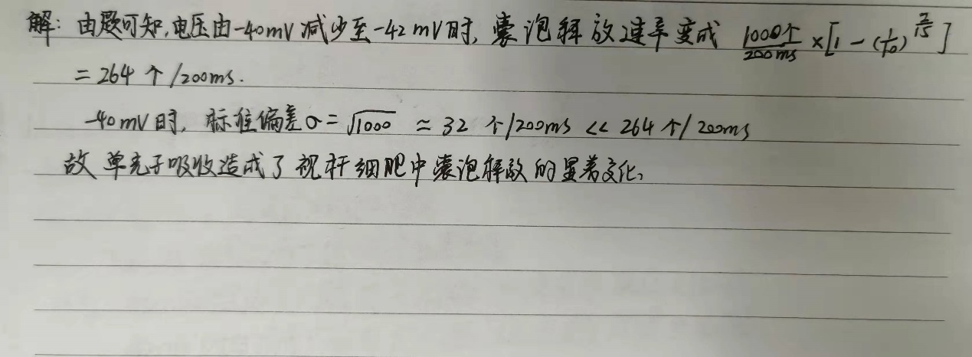

2021.12.16 (3学分)

Why are the calcium-activated chloride channels needed in olfactory transduction?

生活在淡水中的鱼类等，其鼻黏膜内的离子环境被淡水改变为很低的钠离子和氯离子。当水中气味（如氨基酸等）与气味受体结合，钠离子不能通过CNGC通道进入嗅感觉神经元。而胞外的钙离子（胞内外巨大浓度差）可通过CNGC通道进入嗅感觉神经元，通过激活Cl通道使Cl离子外流，增加嗅感觉神经元的去极化，产生强的气味反应。